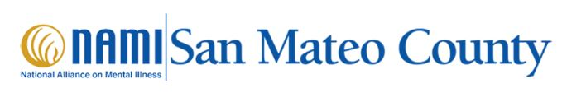

National Alliance on Mental Illness (NAMI)
NAMI San Mateo County
NAMI offers support, education, compassion and practical experience, to anyone needing to educate themselves about mental illnesses and their treatment or a loved one in San Mateo County.

NAMI HelpLine | NAMI: National Alliance on Mental Illness
The NAMI HelpLine is available Monday through Friday 10 am – 10 pm ET 1-800-950-NAMI (6264), text “HelpLine” to 62640 or email helpline@nami.org

Family Programs (courses)
Family-to-Family Program is a free 9-week course for family caregivers of individuals with severe mental illnesses.
NAMI Basics Program is a free 6-week course designed for parents and other primary caregivers of children and adolescents experiencing emotional and behavioral difficulties.

